**ST. MARK UNITED METHODIST CHURCH**

Reverend Mike Bruce

Worship Service 7:00 pm March 5, 2025

***Ash Wednesday***

**INTROIT** “You Are My Hiding Place” by Laner *Chancel Choir*

**PRELUDE** *Chuck Long*

**WORDS OF WELCOME**

**\*CALL TO WORSHIP**

L: Return to me!

**P: Christ calls, and we listen.**

L: Return to me!

**P: Christ calls, we respond.**

L: Return to me!

**P: Christ calls, and we return…to life, to love, to God.**

**\*OPENING PRAYER**

Merciful God, open our hearts to your healing love. Call us anew to amend our ways, as we embark on this Lenten journey. Walk with us and teach us your love, that we might be signs of your grace. With joyous hope we pray. Amen.

**\*HYMN OF PRAISE** “More Love to Thee, O Christ” **UMH 453**

**A MODERN AFFIRMATION** **UMH 885**

**\*GLORIA PATRI UMH 70**

**PSALTER** Psalm 51: 1-17 **UMH 785**

**JOYS AND CONCERNS**

**PASTORAL PRAYER**

**THE LORD’S PRAYER UMH 895**

**ANTHEM** “The Power of The Cross” *by Getty & Townsend**Chancel Choir*

*(Back of Bulletin)*

**\*HYMN OF PREPARATION** “Sunday’s Palms Are Wednesday Ashes” **TFWS 2138**

**SCRIPTURE LESSON Matthew 6: 1-6, 16-21**

**SERMON** SLACKTIVISM *Rev. Mike Bruce*

**THE IMPOSITION OF ASHES**

**\*HYMN OF RESPONS****E** “Near to the Heart of God” **UMH 472**

**\*BENEDICTION**

**\*BENEDICTION RESPONSE** “Threefold Amen” *Chancel Choir*

**\*POSTLUDE**  *Chuck Long*

*\*Please stand (if able)*

**The Power of the Cross**

*Song by Stuart Townend ‧ 2006*

Oh, to see the dawn of the darkest day  
Christ on the road to Calvary  
Tried by sinful men, torn and beaten, then  
Nailed to a cross of wood

This, the power of the cross  
Christ became sin for us  
Took the blame, bore the wrath  
We stand forgiven at the cross

Oh, to see the pain written on Your face  
Bearing the awesome weight of sin  
Ev'ry bitter thought, ev'ry evil deed  
Crowning Your bloodstained brow

This, the power of the cross  
Christ became sin for us  
Took the blame, bore the wrath  
We stand forgiven at the cross

Now the daylight flees, now the ground beneath  
Quakes as its Maker bows His head  
Curtain torn in two, dead are raised to life  
Finished the vict'ry cry

This, the power of the cross  
Christ became sin for us  
Took the blame, bore the wrath  
We stand forgiven at the cross

Oh, to see my name written in the wounds  
For through Your suffering I am free  
Death is crushed to death, life is mine to live  
Won through Your selfless love

This, the power of the cross  
Son of God, slain for us  
What a love, what a cost  
We stand forgiven at the cross

**ST. MARK UNITED METHODIST CHURCH**

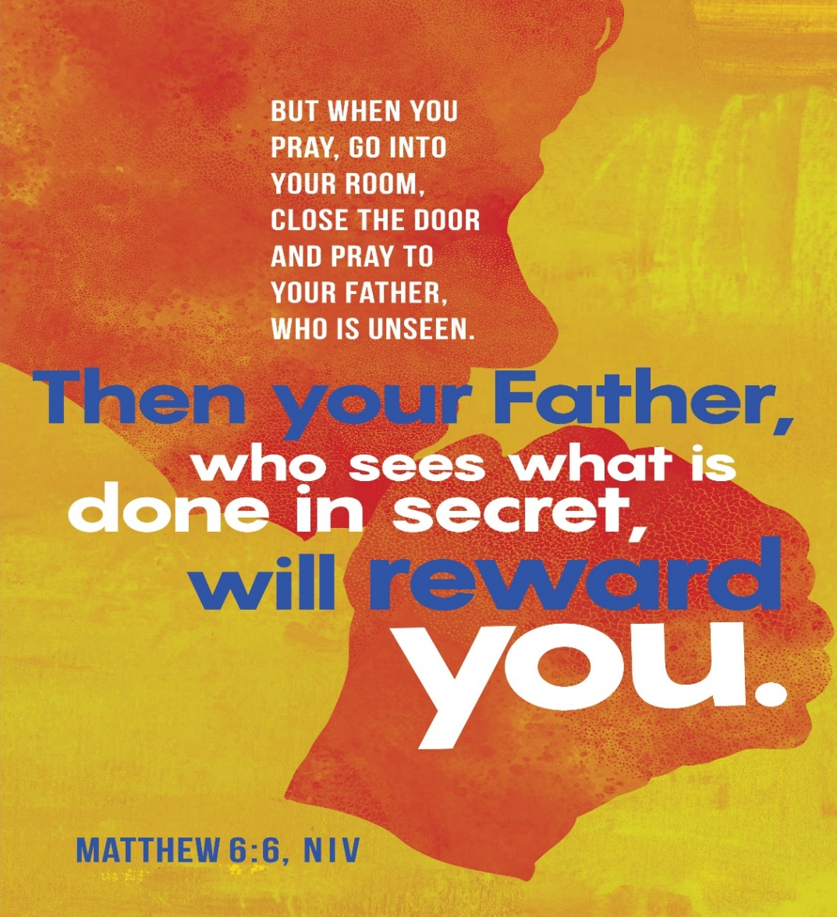

413 Geddes Avenue

Charleston, SC 29407

**Phone:** (843) 766-5239

**Email:** [stmarkumcsec@gmail.com](mailto:stmarkumcsec@gmail.com)

**Church Office Hours:** Monday – Thursday

8:30 am – 1:30 pm